

0 SCHOOL

.P...).n

,.l.

550 Poi r ier Str eet, Coqu it lam, BC Canada V3J 6A7 • Pho n e: 604-939-9201 • Fax: 604-937 -675 8

*Learning for* a *Lifetime*

March 8, 2016

**Re: Emergency Preparedness and Student Release**

Dear Parents & Caregivers:

Emergency Preparedness Week is May 2nd to 6th, and School District 43 and your home school will soon be sending out information to ensure that everyone is aware of the protocols and procedures in place for the safety and well-being of students during an emergency situation.

We appreciate your cooperation on the following:

• If you have not yet done so, please update your child's Emergency Release information.

Your child's school will contact you with a method of doing so.

• Stay informed by reading all information that comes home from the school or district regarding emergency preparedness.

**Student Release**

The safety and well-being of students is important to us. For that reason we are expecting schools to practice a school emergency student release during the week of May 2nd- 6th, with a proposed date of the afternoon of May 4th. Schools will decide the exact timing and degree of the release, based on their context, previously scheduled or unavoidable events, or level of preparation. The goals of these decisions will be to minimize disruption to student learning and parents' schedules.

All our schools have plans for evacuation and release, and it is important to periodically practice those plans to ensure orderly and safe protocols are followed. We have not practiced a district­ wide student release for several years, and we consider it an important training exercise to do for the safety of students. Your understanding and support for this is greatly appreciated.

Lastly, I would like to thank the CTA, CUPE, DPAC, all of the PACs, and community members who have supported schools in preparing for emergency situations. Your continued involvement is important and appreciated.

Th"R_,ou in advance for your cooperation.

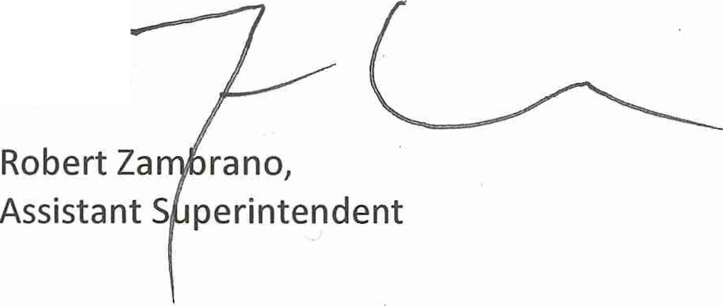

Serving the communities *of* **Anmore, Belcarra, Coquitlam, Port Coquitlam and Port Moody**